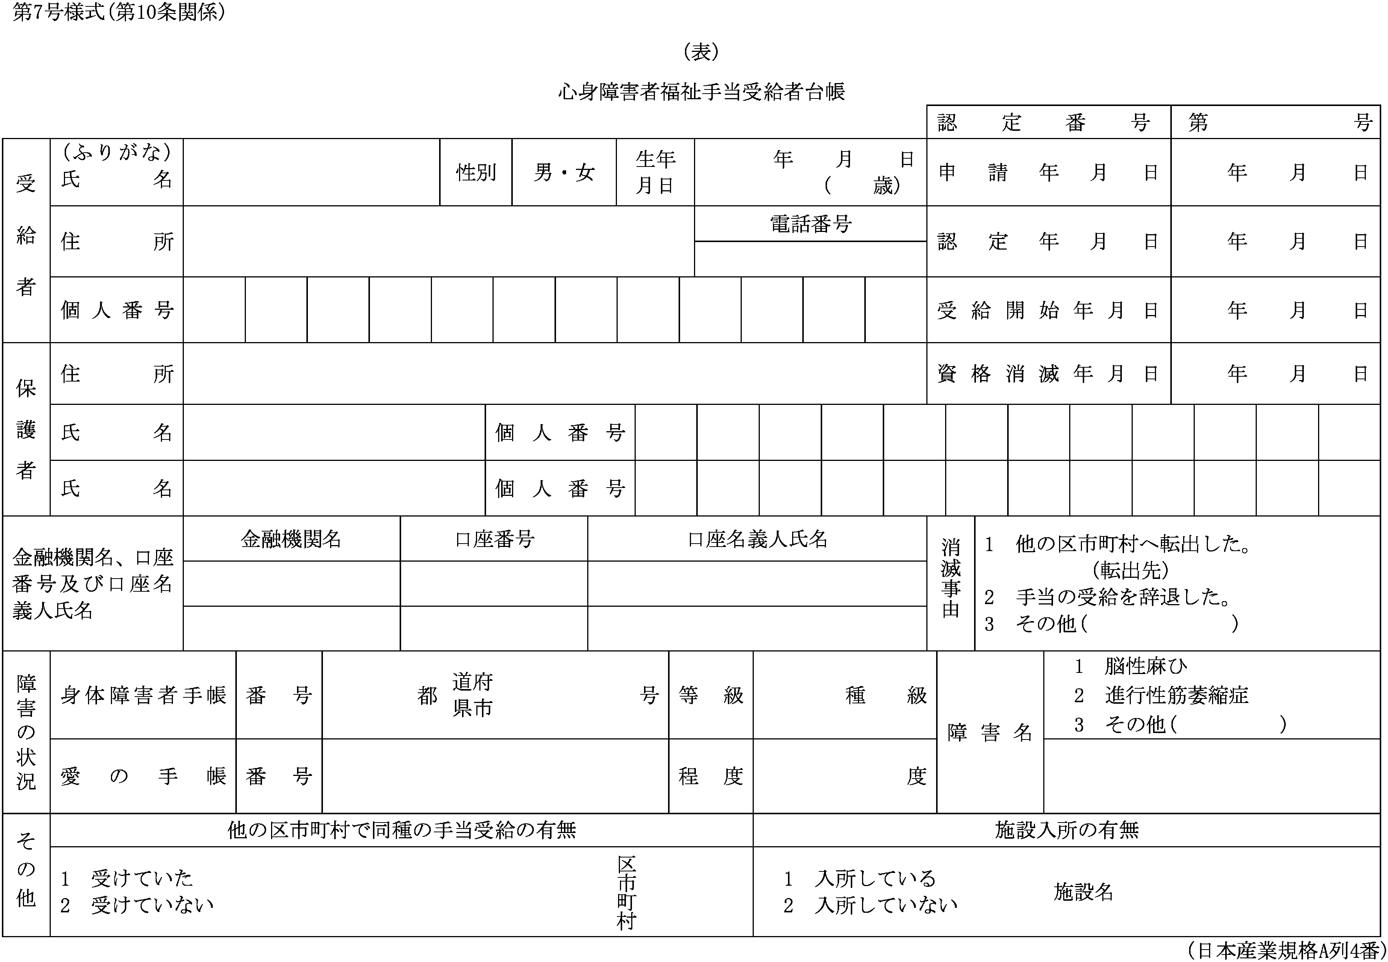

(裏)

|  |  |  |  |  |  |  |  |  |  |  |  |
| --- | --- | --- | --- | --- | --- | --- | --- | --- | --- | --- | --- |
| 認定番号 | | 第　　　号 | | 氏名 |  | | | 受給開始年月 | | 年　　月 | |
| 年度 | 前年の所得 | | 控除額 | | | 控除後の所得額 | 支給月額 | 支給期月及び支給額 | | | |
| 1期(4月) | 2期(8月) | | 3期(12月) |
|  | 円 | | 円 | | | 円 | 円 | 円 | 円 | | 円 |
|  |  | |  | | |  |  |  |  | |  |
|  |  | |  | | |  |  |  |  | |  |
|  |  | |  | | |  |  |  |  | |  |
|  |  | |  | | |  |  |  |  | |  |
|  |  | |  | | |  |  |  |  | |  |
|  |  | |  | | |  |  |  |  | |  |
|  |  | |  | | |  |  |  |  | |  |
|  |  | |  | | |  |  |  |  | |  |
|  |  | |  | | |  |  |  |  | |  |
|  |  | |  | | |  |  |  |  | |  |